|  |  |
| --- | --- |
| No. of Pages | **6** |
| No. of Questions | 7 |

**Department of Computer Science and Engineering**

**FINAL EXAMINATION FALL 2015**

**CSE421/EEE 465: Computer Networks**

**Total Marks: 100 Time Allowed: 3 Hours**

* Answer **Any** **Five (5)** questions out of **Seven (7)** questions.
* Figure in bracket [] next to each question indicates marks for that question.

###### Question No. 1

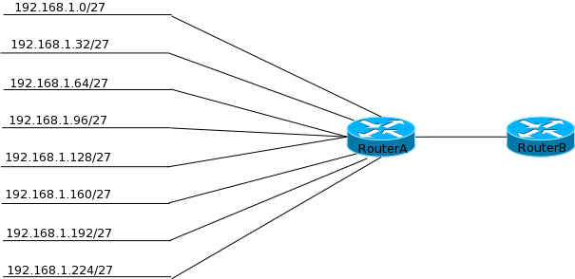

**Figure No. 1**

1. Refer to the figure no. 1 above, Router A is running RIP Routing Protocol. [3+1.5+1.5 marks]
   1. The administrator wishes to manually summarize the network addresses to a single address, calculate the summarized address and mask.
   2. Write a static route for that single address
   3. And send that static route information via RIP to RouterB.

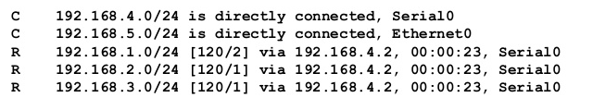

**Figure No. 2**

1. Refer to figure No. 2, the output is the routing table of Router R1, after 7 seconds Router R1 receives a routing update, but that update has no information of the network 192.168.2.0/24. What will router R1 do regarding 192.168.2.0/24 network? When will it remove it from the routing table? [4+2 marks]

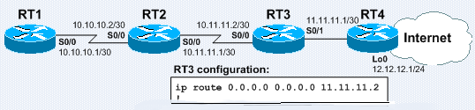

**Figure No. 3**

1. Based on the figure no. 3 shown above, what needs to be configured in RT3, so that RT1 and RT2 has easy access to the Internet via RT4? RT1, RT2 and RT3 are all running RIPv2 routing protocol. Should RT3 and RT4 run RIPv2 or not, explain? [2.5+2.5 marks]

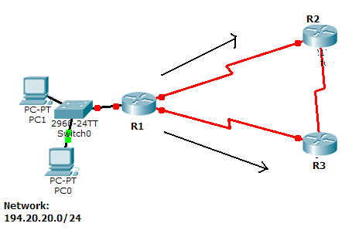

**Figure No. 4**

###### Refer to figure no. 4 above, R1 sends an update to R2 and R3. Next R2 sends an update with information regarding 194.20.20.0/24 network to R3. Will R3 send the same information regarding 194.20.20.0/24 network back to R1? Explain your answer. [3 marks]

###### Question No. 2

1. You get a call from a network administrator who tells you that he typed the following into his router as shown in figure no. 5:

**Figure No. 5**

Router(config)#router ospf 1

Router(config-router)#network 10.0.0.0 255.0.0.0 area 0

He tells you he still can't see any routes in the routing table. What configuration error did the administrator make? And explain what the “1” represents written after “router ospf”. [4 marks]

1. There are three possible routes for a router to reach a destination network. The first route is from OSPF with a metric of 782. The second route is from RIPv2 with a metric of 4. The third is a static route configured by the administrator. Which route will be installed by the router in its routing table and why? [3 marks]

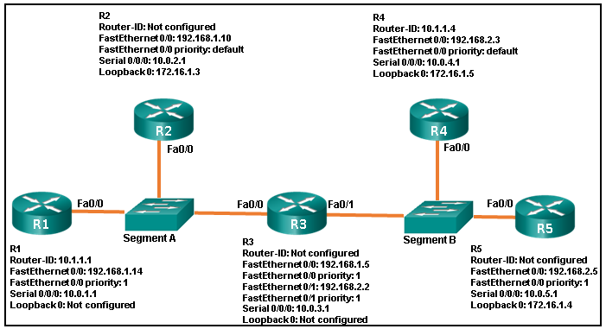

**Figure No. 6**

1. Refer to figure no. 6 above; identify all the router IDs and the DR and BDR. [Marks 5+1+1]
2. For two routers to become OSPF neighbors, what information needs to match? [3marks]

###### Question No. 3

1. Refer to the figure no. 7 below; Router R1 is configured as the DHCP server for the network 172.18.32.0/24 as shown. The users are faced with several problems.
   1. The users are not able to access the web server using [www.techno.com](http://www.techno.com) via their web browser, but they are able to ping the web server using 172.18.32.252. Find and solve the problem.
   2. The users are not able to access any sites over the Internet, find and solve the problem. [2.5+2.5 marks]

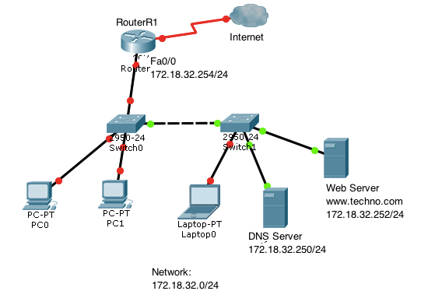

<output omitted>

ip dhcp-excluded address 172.18.32.249 172.18.32.253

ip dhcp pool techno

network 172.18.32.0 255.255.255.0

default-router 172.18.32.253

!

interface FastEthernet 0/0

ip address 172.18.32.254 255.255.255.0

duplex auto

speed auto

!

<output omitted>

**Figure No. 7**

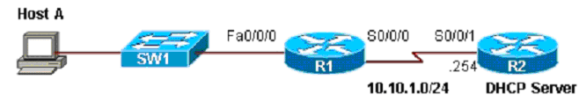

**Figure No. 8**

1. Host A is not able to receive any IP configuration from the DHCP server shown in figure no.8? What could be the reason/s? And how to solve the problem? [4 marks]
2. Differentiate between public and private IP addresses? [3 marks]
3. What commands are used to statically map the following private address 10.0.0.10 / 24 to the public address 141.63.7.20 / 28 using NAT? When do we need this kind of static mapping? [4 marks]
4. Refer to figure no. 9 below. What are the reasons that explain why none of the workstations are able to access the Internet? [4 marks]

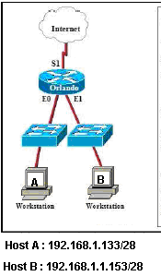

**Figure No. 9**

Orlando#show running-config

<-output omitted->

Hostname Orlando

!

interface Ethernet0

ip address 192.168.1.129 255.255.255.240

ip nat outside

!

interface Ethernet1

ip address 192.168.1.145 255.255.255.240

!

interface Serial1

ip address 201.201.201.1 255.255.255.0

ip nat inside

!

ip nat pool Sales 201.201.201.5 201.201.201.15 netmask 255.255.255.0

!

access-list 1 permit 192.168.1.0 0.0.0.255

<output omitted>

###### Question No. 4

1. Determine the compact IPv6 address of the following hosts : [2+2+1 marks]
   1. 203c: 0fdc:0000:0:0000:0: 201:1bc5
   2. 30f:0:0:0000:3034:0:0000:0
   3. 0:0000:0:0:0000:0000:0000:0001
2. What is the purpose of the ‘Next Header’ field in IPv6 packets? And how are they linked if multiple headers are present? [1+3 marks]
3. What will be the EUI-64 bit address for a device with MAC address 0021:2fb5:6e10. Don’t forget to invert the U/L bit. [3 marks]
4. How is anycast different from multicast? [2 marks]
5. Draw the process of stateless DHCPv6. [6 marks]

###### Question No. 5

Switch# show port-security interface f0/18

Port Security : Enabled

Port Status : Secure-up

Violation Mode : Shutdown

Aging Time : 0 mins

Aging Type : Absolute

Secure Static Address Aging : Disabled

Maximum MAC Addresses : 1

Total MAC Addresses : 1

Configured MAC Addresses : 0

Sticky MAC Addresses : 0

Last Source Address:Vlan :001c.0a0f.0032:10

Security Violation Count : 0

**Figure No. 10**

1. Refer to the figure no. 10, PC1 (001c.0a0f.0032) is connect to interface fa0/18.
   1. What happens if Attacker-PC2 disconnects PC1 and tries to gain access to fa0/18? [3 marks]
   2. Can Attacker-PC2 gain access after switch reboots? If yes, mention two approaches which will restrict Attacker-PC2 from connecting to fa0/18? Explain your answer.

[1+3+3 marks]

1. In switches that have the AUTO-MDIX feature is helpful, why? [2 marks]
2. Switch is a layer 2 device still we configure it with an IP address. Why? [2 marks]
3. Layer 3 switches do not completely replace the need for routers on a network. Explain. [3 marks]
4. Lack of security on switch ports leads to several vulnerabilities explain one. [3 marks]

###### Question No. 6

1. All the ports of a switch lies on the same broadcast domain, how can we split this domain? [1 mark]
2. A trunk link can carry packets from more than one VLAN. How does it differentiate among different VLAN packets once it reaches an access link? [3 marks]
3. Differentiate between native and management VLAN [3 marks]
4. DTP (Dynamic Trunking Protocol) could create problems during trunk negotiation give an example. [3 marks]
5. Refer to figure no. 11. What happens if **172.17.2.11** sends a packet to **172.17.2.66** via interface f0/0? What the packet was destined for **172.17.2.50**? [2+4 marks]

R1(config)#**int f0/0.1**

R1(config-subif)#**encapsulation dot1q 10**

R1(config-subif)#**ip address 172.17.2.10 255.255.255.192**

R1(config-subif)#**end**

R1(config)#**int f0/0.2**

R1(config-subif)#**encapsulation dot1q 20**

R1(config-subif)#**ip address 172.17.2.74 255.255.255.192**

R1(config-subif)#**end**

R1(config)#**int f0/0.3**

R1(config-subif)#**encapsulation dot1q 30**

R1(config-subif)#**ip address 172.17.2.138 255.255.255.192**

R1(config-subif)#**end**

R1(config)#**int f0/0**

R1(config-if)#s**hutdown**

R1(config-subif)#**end**

**Figure No. 11**

1. Differentiate between the following two commands [4 marks]
   1. S1(config-if)# no switchport access vlan 20
   2. S1(config)# no vlan 20

###### Question No. 7

1. You have written a numbered ACL in a router with 3 statements/conditions. Now you wish to insert another statement/condition between the 2nd and 3rd condition. What steps should you follow to achieve this? [4 marks]

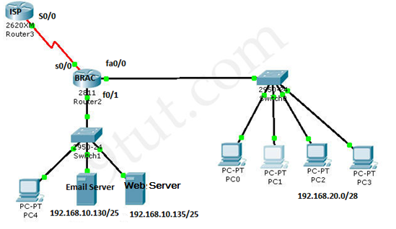

**Figure No. 12**

1. Refer to the figure no.12 above, the network administrator wishes to block PC1 (192.168.20.3) any email access to the email server. All other traffic from the network 192.168.20.0 is allowed to go through. Also nobody from outside of BRAC Router can ping the email server. Write the ACLs and place it properly. [8 marks]
2. How IPv6 and IPv4 ACLs are different? [4 marks]
3. Write a named ACL that will only allow hosts of 192.168.10.128/25 network to telnet into the BRAC router. DO not forget to place the ACLs appropriately. [4 marks]

##### THE END